
CONFIDENTIAL CS/NOV 2026/CSC429

UNIVERSITI TEKNOLOGI MARA FINAL EXAMINATION

COURSE
COURSE CODE
EXAMINATION TIME
COMPUTER ORGANIZATION AND ARCHITECTURE

CSC429
NOVEMBER 2026
3 HOURS

INSTRUCTIONS TO CANDIDATES

- This question paper consists of two (2) parts: PART A (10 Questions) PART B (1 Question)

- Answer ALL questions in the Answer Booklet. Start each answer on a new page.

- Do not bring any material into the examination room unless permission is given by the invigilator .
- Please check to make sure that this examination pack consists of: i) the Question Paper
  - an Answer Booklet - provided by the Faculty

- Answer ALL questions in English.

DO NOT TURN THIS PAGE UNTIL YOU ARE TOLD TO DO SO

This examination paper consists of 6 printed pages.

PART A (80 MARKS)
Answer ALL questions in this part.
QUESTION 1 (5 marks)
Question 1 is based on the following statement.
Mr. X is known as Father of Computer. He developed Analytical Machine in
1837 which has four main components, namely; memory, the mill, punch card
reader and the punch and printed section. Analytical Machine is the successor
of Y machine. Y machine is used to compute tables of numbers for naval
navigation.
- Name the inventor of Mr. X.
- Identify the name of Y machine.
- What is the function of Analytical Machine?
- Map the components Analytical Machine to Von Neumann architecture
QUESTION 2 (5 marks)
- How classification of parallel processor is constructed?
- Give ONE (1) example for each parallel processor architecture.
QUESTION 3 (5 marks)
The advancement of technology through different computer generations has focused on
improving performance, speed, and efficiency. From vacuum tubes in the first generation to
modern Al-powered systems, each generation introduced faster processing, smaller
components, and greater reliability.
- Name the inventor of the following devices:
- Mechanical Calculating Machine
- Analytical Machine
iiD
IAS Machine
- Why are the machines of later computer generation designed for general purposes instead
of the eadier computer generation that is more specific in function?
QUESTION 4 (5 marks)
- \Mat is a bit?
- Given a system of vacuum tubes where each tube represents a single bit with two states:
ON=1 and OFF=O. ldentify the number of vacuum tubes needed to store the value of gro.
Show your workflow to justify your answer.
- Binary system.
- Octal system.
QUESTION 5 (10 marks)
- Discuss TWO (2) functions of an input/output module.
- External input/output devices can be broadly categorized into three categories. List
TWO (2) of the categories and provide an appropriate example of devices for each
categories.
- Name ONE (1) input/output technique that requires active CPU intervention and ONE
(1) technique that does not require CPU intervention.
QUESTION 6 (10 marks)
- ldentify the correct access method based on the following scenario
Access method
Scenario
Readi
I
files.
c file from a folder.
Accessi
a
Streami
files line
line.
Accessin
AS ecific file block usi
an index in a la
e file.
toas
cific frame or a timestam
in the video.
Jum
tn
- Rank the following memory types based on the most to the least storage capacity'
Main memory, Tape, Ll Cache, Hard drive, ReBister, L3 Cache
- Discuss the term volatile from the perspective of computer memory.
QUESTION 7 (10 marks)
- Convert -81.21875 to a floating point number in IEEE single precision format in
hexadecimal value form. Show your complete workflow.
- Convert 43A37C00h in IEEE single precision floating point number to decimal value form.
Show your workflow.
QUESTION 8 (10 marks)
Question 7 is based on Figure 1.
Define intenupt.
- ldentify the intemrpt that has the highest priority with relevant justification

- ldentify the interrupt that has the lowest priority with relevant justification
- Rank the sequence of the intem.rpt process completed ff the computer system applies the
defined priority concept to handle multiple intemrpts.
- Rank the sequence of the interrupt process completed if the co
mputer system aPPlies the
disable nested interrupt concept to handle multiple interrupts'
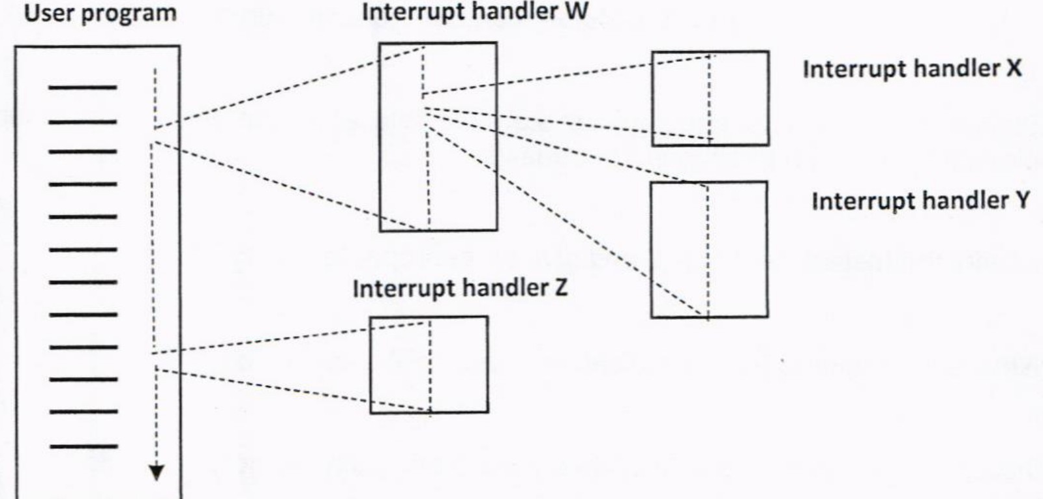
Figure 1: Nested interrupts
QUESTION 9 (10 marks)
- When is an l/O module installed?
- What will happen if the l/O module is not installed?
- Explain ONE (1) category of l/O module
- What does it mean by 'hot connection'?
- List THREE (3) common interfaces to external devices.
QUESTION 10 (10 marks)
- Discuss the main function of cache memory.
- How can the data stored in the cache and main memory be synchronized.
- Contrast between SRAM and DRAM based on the following characteristics:
Type of storage
ii,
Availability of charges leak
price
Example of location of memory usage

PART B (20 MARKS)
Answer the question in this part.
QUESTION 11 (20 marks)
Question 1 is based on Figure 2 and Table 1
Write an appropriate program using conect assembly language notations to compute the
equation shown in Figure 2 using instructions for zero-address, one-address, and three-
address. The available instructions are provided in Table 1. The registers labeled A, B, C, and
D are fixed, while registers x, y, and z can be used temporarily. The final answer must be
stored in register z.
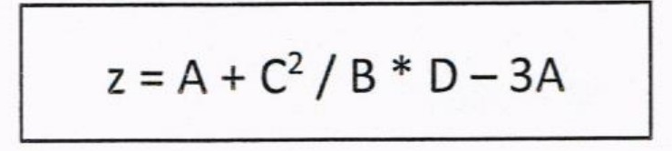
Figure 2
Table 1: lt/achine instruction
Zero-address | One-address | Three-address
PUSH p | LOAD p | ADD (p,q,r)
POP p | STOR p | SUB (p,q,r)
ADD | ADD p | MUL (p,q,r)
SUB | SUB p | DIV (p,q,r)
MUL | MUL p
DIV | DIV p

